

FURTHER MATHEMATICS
TRIAL EXAMINATION 1
SOLUTIONS
2007

Section A – answers Section B – answers

Core Module 1 Module 2 Module 3 Module 4 Module 5 Module 6
Number Geometry Graphs Business Networks Matrices
patterns and and related and
trig relations maths decision

maths
1. A 1. C 1. C 1. C 1. B 1. D 1. C
2. E 2. B 2. D 2. E 2. A 2. E 2. B
3. B 3. B 3. C 3. B 3. B 3. B 3. A
4. D 4. B 4. B 4. A 4. E 4. B 4. D
5. A 5. C 5. C 5. D 5. D 5. C 5. E
6. C 6. D 6. C 6. B 6. B 6. A 6. A
7. C 7. E 7. E 7. C 7. B 7. D 7. E
8. C 8. A 8. C 8. E 8. C 8. C 8. C
9. B 9. E 9. D 9. C 9. A 9. B 9. D
10. D
11. C
12. E
13. D

SECTION A - solutions

Core

Question 1

The data represented by the box plot is negatively skewed since the data values are grouped to the right hand side of the distribution and gradually tail off to the left.
The answer is A.

Question 2

A piece of data is classified as a possible outlier if it is greater than 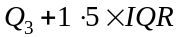 (or less than 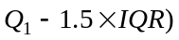.
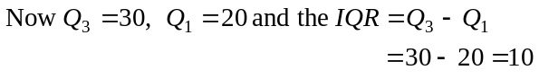
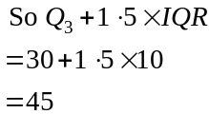
Since 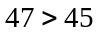 it is a possible outlier.
The answer is E.

Question 3

The two variable in the distribution are type of dining room usage and gender. These are both categorical variables.
The answer is B.

Question 4

The percentage of female members at the sporting club who make occasional use of the dining room is
The answer is D.

Question 5
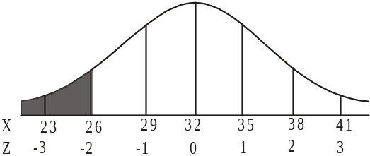

95% of the population with a normal distribution lie within 2 standard deviations either side of the mean. Therefore 5% lies outside that and because of the symmetry of the normal curve, 2.5% lie below 2 standard deviations below the mean which is where the time 26 minutes lies 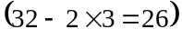.
So 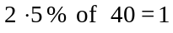
So 1 member of the random sample is expected to take less than 26 minutes.
The answer is A.

Question 6

Use a calculator to obtain r, the Pearson product moment correlation coefficient.
(to 4 decimal places)
The answer is C.

Question 7

For the least squares regression line given by 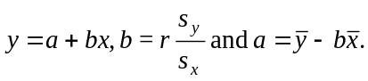
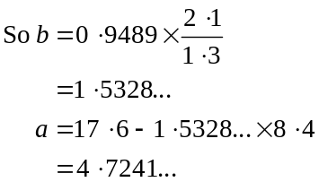
So 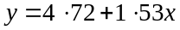 is the least squares regression line where a and b have been expressed correct to 2 decimal places.
The answer is C.

Question 8

A 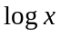 transformation compresses the larger x-values and would be appropriate.
A transformation also compresses the larger x-values.
Either of these would be suitable.
The answer is C.

Question 9

For the original data, the piece of data with an x-value of 0.5 had a y value of 2.
For the transformed data, the piece of data with an x-value of 0.5 had a 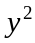 value of 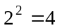.
The least squares regression line for this transformed data is 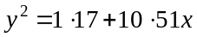.
When 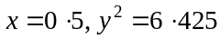.
Now the residual value = actual value – predicted value (from the formula sheet)
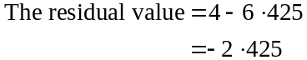
The answer is B.

Question 10

Using the five moving mean smoothing method, the smoothed value for June is
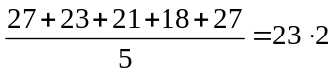
The answer is D.

Question 11

The seasonal indices should add to four.
The seasonal index for the number of patients presenting in spring is 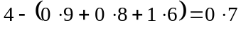.
The answer is C.

Question 12

A seasonal index of 1.6 tells us that the number of patients presenting in winter is typically 60% above the quarterly average.
The answer is E.

Question 13

The deseasonalised number of patients forecast to present is given by
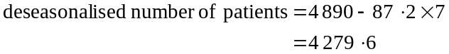
Note that since summer of 2007 represents quarter 1, winter of 2008 represents quarter 7.
The actual number of patients forecast to present in winter 2008 is given by
The answer is D.

SECTION B

Module 1: Number patterns

Question 1

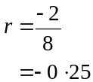
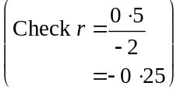
The answer is C.

Question 2

The difference between the fifth and the third term is .
Therefore the difference between two successive (eg. the fifth and the fourth term) is .
Since the third term is 25, the second term is .
The first term is therefore .
The answer is B.

Question 3

We have an arithmetic sequence with 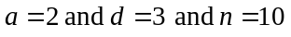.
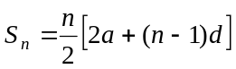 (from the formula sheet)
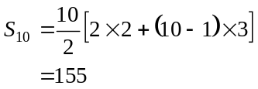
The answer is B.

Question 4

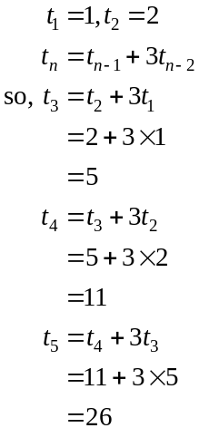
The answer is B.

Question 5

The amount of olive oil being exported will increase by a different, increasing amount each year, because it is a percentage increase.
Therefore the only graph that shows such an increase is graph C.
Graphs D and E show a decrease. Graph B shows an increase but by a decreasing amount each year.
Graph A shows constant increase each year.
The answer is C.

Question 6

From the graph, the sequence is 10, 15, 25, 45, 85.
The sequence generated by option:
A is 10, 15, 22.5,…
B is 10, 15, 20,…
C is 10, 20, 30,…
D is 10, 15, 25, 45, 85
E is 10, 10, 10,…
The answer is D.

Question 7

The difference equation defined by 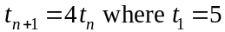 describes the geometric sequence
5, 20, 80, 320,… whereby
The rule for this geometric sequence is 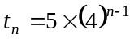
The answer is E.

Question 8

The sequence is 840, 168, 33.6,…
It is not an arithmetic sequence since 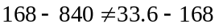.
It is however a geometric sequence since 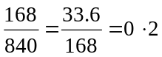.
So .
The sum to infinity of this geometric sequence is given by
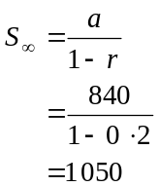
The answer is A.

Question 9

The number of dogs increases by 40% each year so that 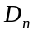 needs to be multiplied by 1.4.
So 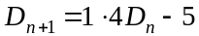 since the 5 dogs were sold at the end of the year after the 40% increase had occurred.
The answer is E.
Module 2: Geometry and trigonometry

Question 1
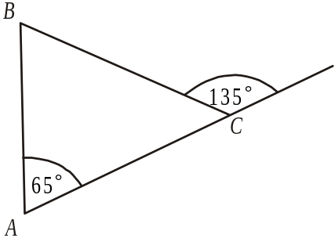

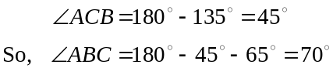
The answer is C.

Question 2

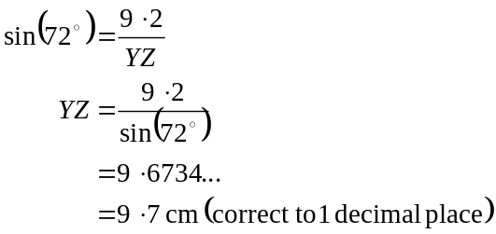
The answer is D.

Question 3

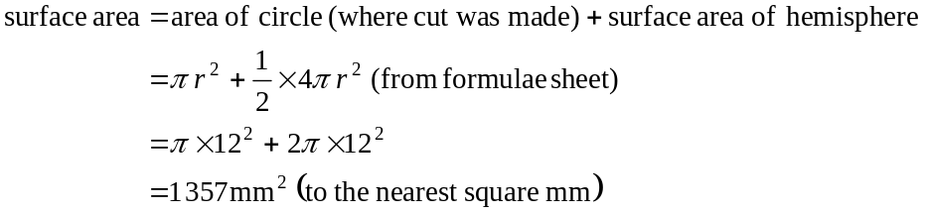
The answer is C.

Question 4

We have 2 sidelengths and the included angle so use the formula
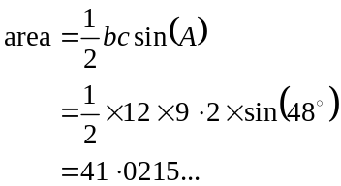
The closest answer is 41cm.
The answer is B.
Question 5

Draw a diagram.
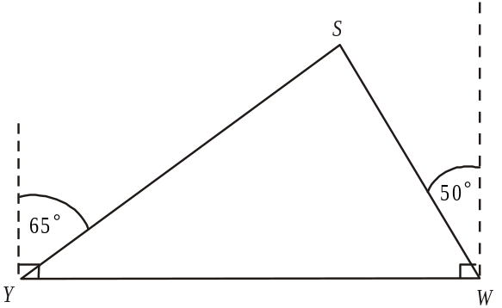

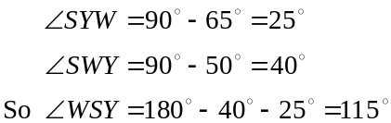
The answer is C.

Question 6

Because the two triangles are similar and the ratio of the shortest sides is ; the

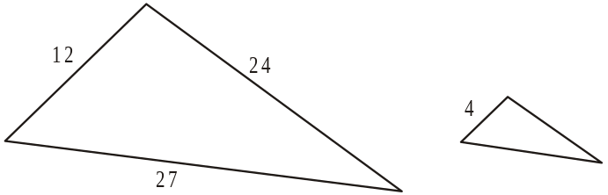

longest side of the smaller triangle must be 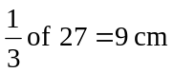 and the middle length side must be 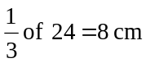.
The perimeter is therefore 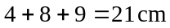.
The answer is C.

Question 7
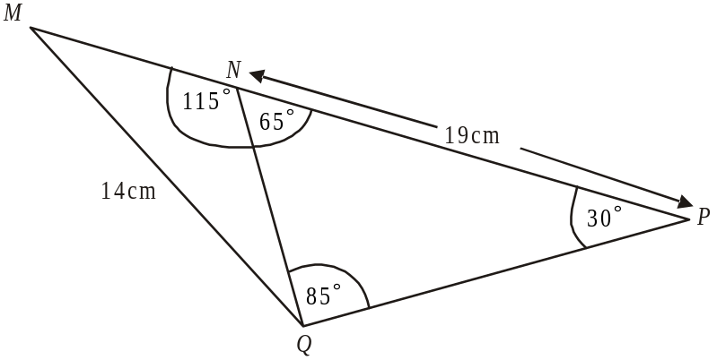

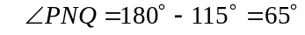.
Also, 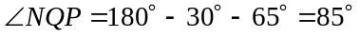
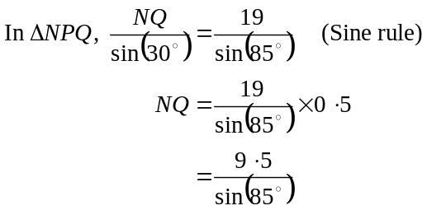
The answer is E.

Question 8

The model and the actual land are similar shapes.
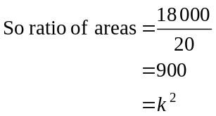
where k is the scale factor of the length of sides of the model and the actual land.
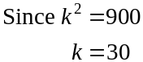
Since the eastern border of the model is 4m long, the eastern border of the actual land is long.
The answer is C.

Question 9
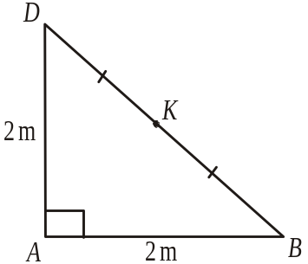
In ,
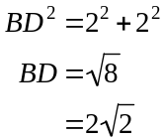
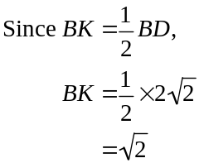
In 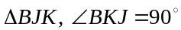,
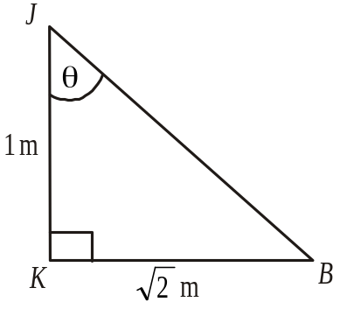
since JK is vertical.
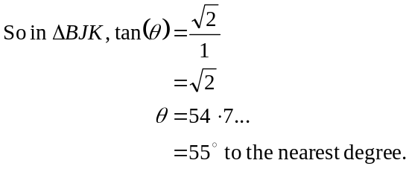
The answer is D.

Module 3: Graphs and relations

Question 1

The graph of is a vertical line through 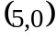.
The graph of 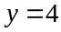 is a horizontal line through 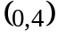.
The graph of 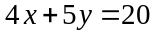 has an x intercept of and a y intercept of .
The graph of 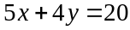 has an x intercept of 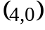 and a y intercept of 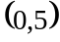.
The graph of 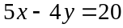 has an x intercept of and a y intercept of 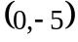.
The answer is C.

Question 2

The relative humidity at Melbourne airport is decreasing between noon and 3pm and again between midnight and noon. This represents a total of 15 hours.
The answer is E.

Question 3

The cargo plane is stationary when its distance is not changing; that is, when the line is horizontal.
This is the case between 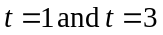; that is, for 2 hours.
The answer is B.

Question 4

Between ,
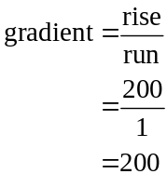
y-intercept is 0.
The rule is 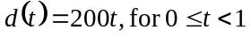.
Between 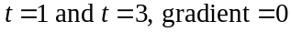.
The rule is 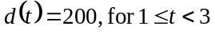.
Between ,
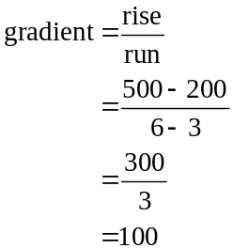

y-intercept is – 100 (place a ruler along this section of the graph and trace the line back until it hits the y-axis). This happens at 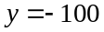. The rule is 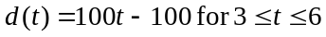.
Alternatively, using the formula 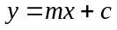, we have
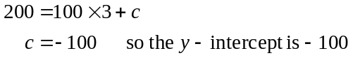
The rule is .
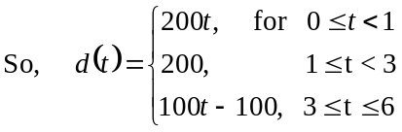

The answer is A.

Question 5

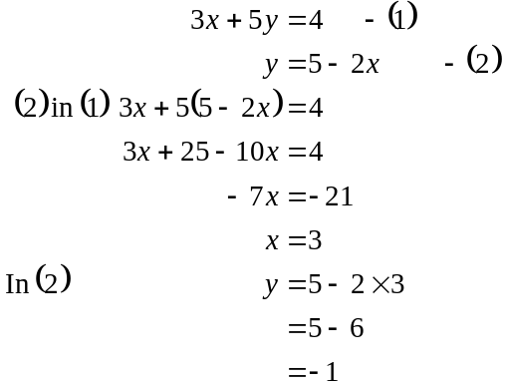
The solution is 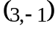.
The answer is D.

Question 6

At P, 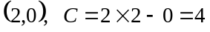
At Q, 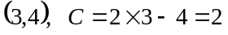
At R, 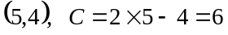
At S, 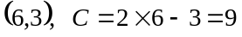
At T, 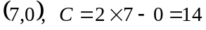
The minimum value of C occurs at point Q.
The answer is B.

Question 7

The graph of y versus 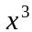 for the function 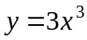 will be a linear (straight line) function passing through the point 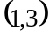.
Note that for the options A and D, the axes are x and y. For y versus x the function will be cubic in shape and not linear.
The answer is C.

Question 8

For James, 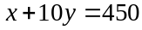 where x is the annual membership fee and y is the fee per game.
For Andrew, 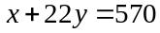.
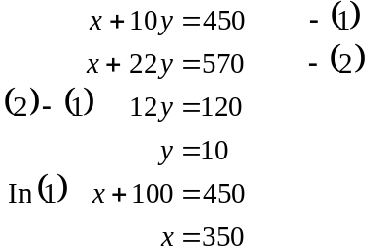
The annual membership is $350.
The answer is E.

Question 9

x = number of apple pies
y = number of apple turnovers
For apple, 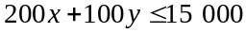
For pastry, 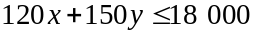
The answer is C.

Module 4: Business-related mathematics

Question 1

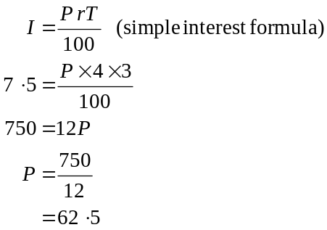
There was $62.50 in Sam’s money box.
The answer is B.

Question 2

To find the amount of GST charged on an item, divide by eleven.
So, 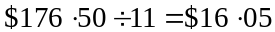 (to the nearest cent).
The answer is A.

Question 3

At the end of the first year, Suzie’s investment is worth
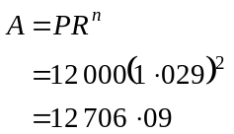
At the end of the second year, Suzie’s investment is worth
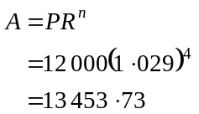
During the second year she has earned .
The answer is B.

Question 4

The washing machine will depreciate by 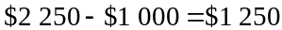.
This represents 125 000 cents.
Now
The answer is E.

Question 5

Therese pays a deposit of $159 which leaves a balance of 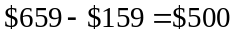.
She pays a total of 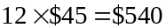 over the coming year.
This represents a total of $40 in interest paid.
The annual flat rate of interest she pays is given by 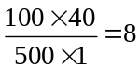.
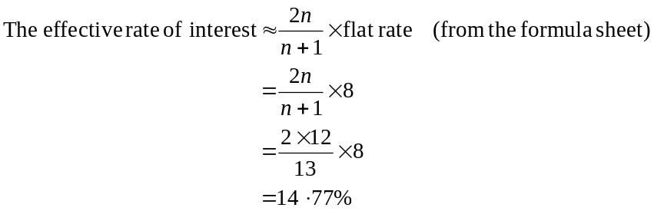
The answer is D.

Question 6

The balance increases by an equal amount every six months. The interest cannot therefore be compound otherwise the amount would increase by an increasing amount each 6 months. The interest is simple, paid on the opening balance and added to the account each 6 months.
The answer is B.

Question 7

For July, the minimum balance is $4 329.18, as it is for August and September.
For October, the minimum balance is also $4 329.18. For November it is $4 379.18 and for December it is $4 111.86.
The annual interest rate is 6%.
The monthly interest rate is 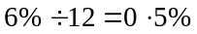.
The balance on 31 Dec 2006 will be $4240.90.
The answer is B.

Question 8

Using TVM solver we have,

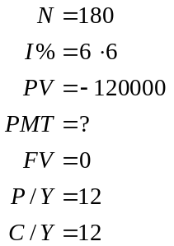
The monthly payment is $1 051.94.
The answer is C.

Question 9

Using TVM solver, it will take Genevieve 5 years to pay out the loan with an interest rate of 7.6% i.e.

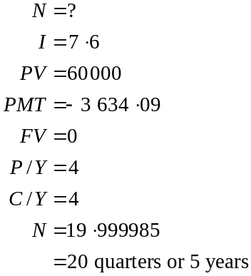

After 1 year or 4 quarters the amount left owing on the loan is $49 735.70 using TVM solver i.e.

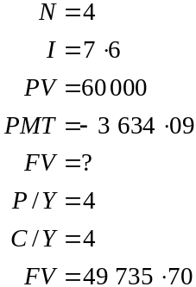

To see how long it takes to pay off this amount when the rates go to 8.6% use TVM solver again i.e.

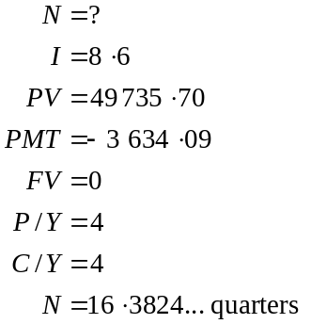

This means that it takes an extra 0.3824… of a quarter or 0.3824 of a 3 month period which approximates to one month.
The answer is A.

Module 5: Network and decision mathematics

Question 1

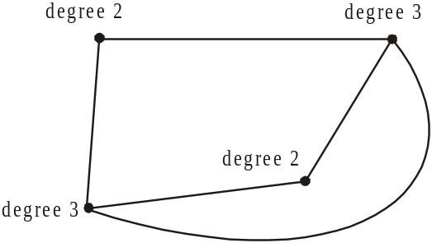

The sum of the degrees of all the vertices is .
The answer is D.

Question 2

An Euler path passes through each arc just once.
Note that vertices D and E both have an odd number of vertices. If we start on one of these vertices and finish on the other, an Euler path will be formed. That is, EABCDBED is one such path.
The answer is E.

Question 3

Using trial and error the shortest path is to travel along the paths with lengths
The answer is B.

Question 4

Euler’s formula applies to planar graphs; that is, graphs that can be drawn so that no edges cross. This can be achieved with options A, C, D and E but not with B.

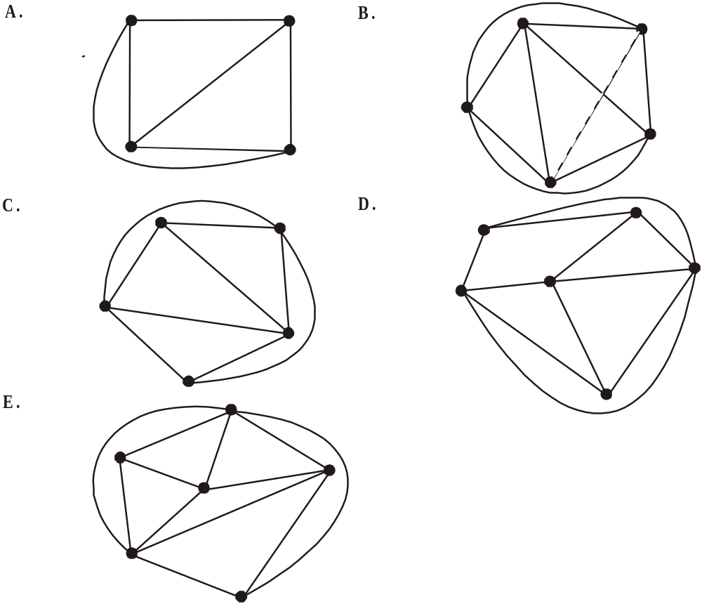

The answer is B.

Question 5

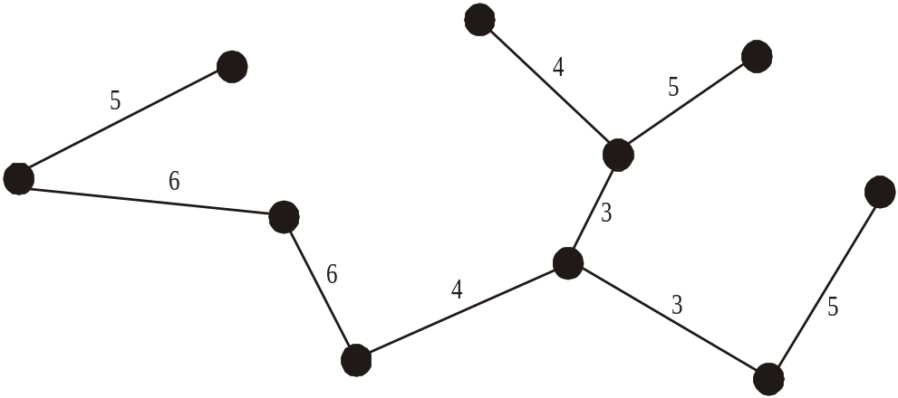

The minimum spanning tree is shown above. It started at one of the edges with a length of 3 and extended via the branches with the shortest length until all vertices belonged to it.
The total length is
The answer is C.

Question 6

A and B have no immediate predecessors so option B is incorrect.
D’s immediate predecessor is B so option C is incorrect.
G’s immediate predecessor is F so option E is incorrect.
J’s immediate predecessors are E and G so option D is incorrect.
The answer is A

Question 7
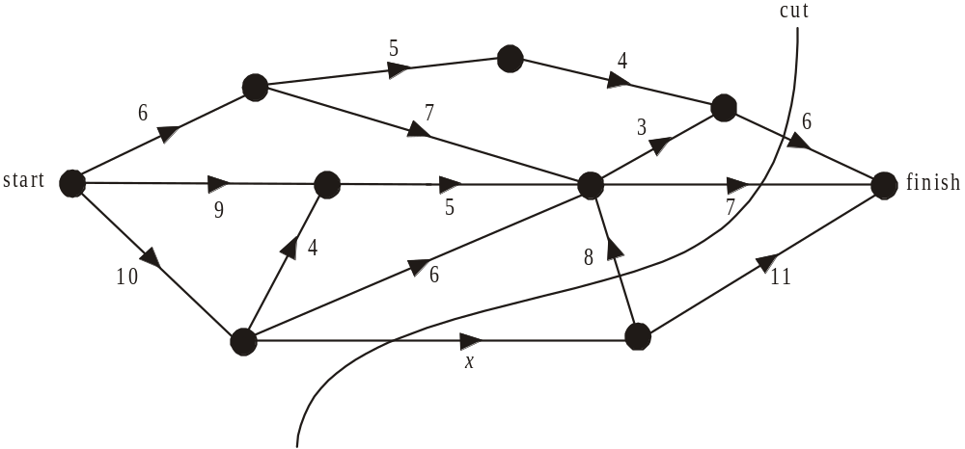

There are no cuts possible with a capacity of 18 that don’t include side x.
The cut shown has a capacity of . It is the lowest cut possible with the next lowest having a capacity of .
Note that the side with a flow of 8 is flowing from finish to start across the cut and so is counted as 0.
Since the maximum flow is 18, the minimum cut must be 18 so .
The answer is D.

Question 8

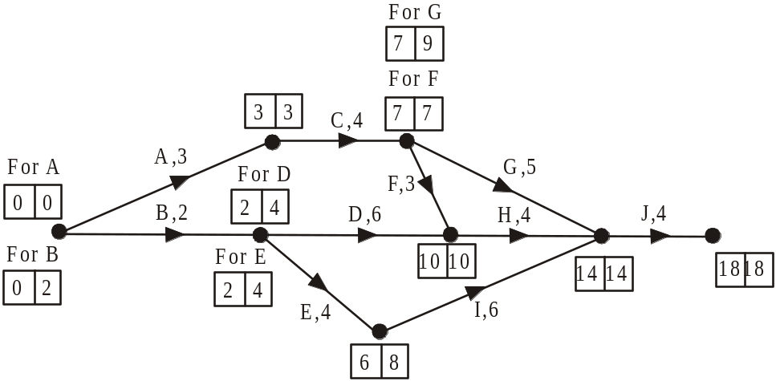

The left hand number in the boxes near the vertices gives the earliest start time for the activity. The right hand number gives the latest start time for the activity. The critical path is ACFHJ since the earliest and latest start times are equal for the activities on that path.
The length of the path is therefore .
The answer is C.

Question 9
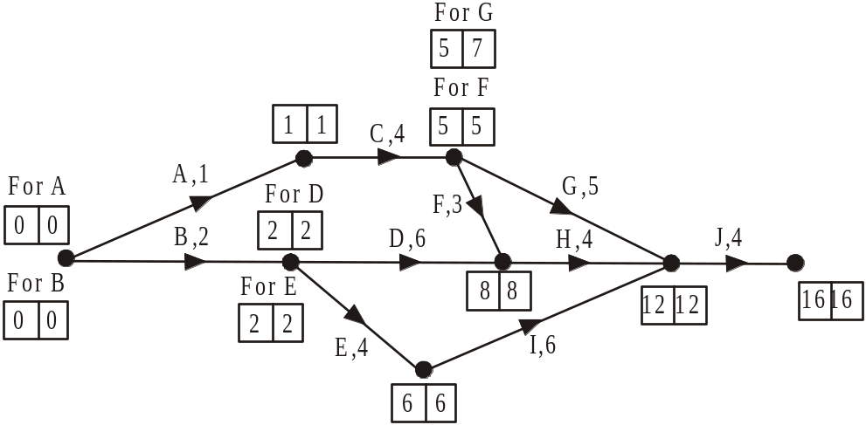

The only activity for which the earliest start time doesn’t equal the latest start time is activity G. All other activities are critical. So there is one activity that doesn’t lie on a critical path.
The answer is B.
Module 6: Matrices

Question 1

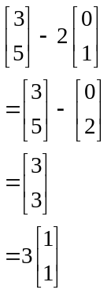
The answer is C.

Question 2

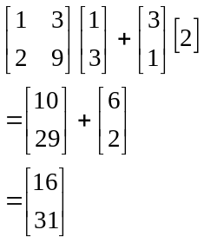
The answer is B.

Question 3

Matrix A has order 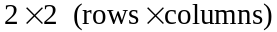
Matrix B has order
Matrix C has order
The matrix product AB does not exist because the number of columns of A does not equal the number of rows of B.
The answer is A.

Question 4

Enter matrices A and B on your calculator.
Calculate 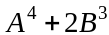.

The answer is 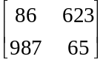.
The answer is D.

Question 5

In 2006, SM won 2 and CG won one and HH won none.
In 2005, each salon won one each.
In 2004 HH won two, CG won one and SM won none.
Only option E shows this.
The answer is E.

Question 6

M is a 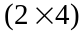 matrix.
The matrix product AM is a 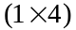 matrix.
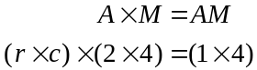
The number of columns of A must equal the number of rows of M so A has 2 columns.
The number of rows of A gives the number of rows of AM so A has 1 row.
Therefore A has order 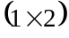.
The answer is A.

Question 7

A set of simultaneous equations has a unique solution, if, when the set is expressed in matrix form 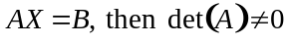.
For set 1, 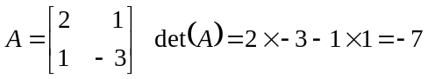
For set 2, 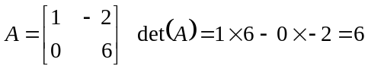
For set 3, 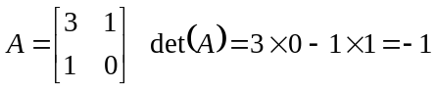
Since 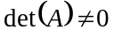 for all these sets, they all have a unique solution.
The answer is E.

Question 8

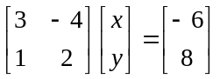
The inverse of the matrix 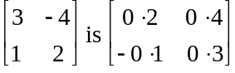.
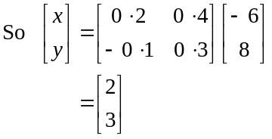
The answer is C.

Question 9

Store A is reducing its prices by 10% which means that current prices need to be multiplied by 0.9. Similarly prices at Store B need to be multiplied by 0.8.
Since we want the new price matrix to have order 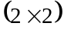 and the current price matrix has order we need to multiply by a matrix.

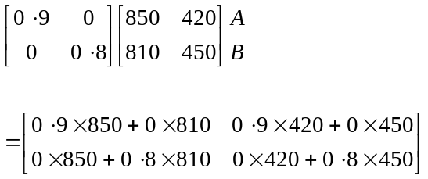

Note that Store A prices are multiplied by 0.9 and Store B prices are multiplied by 0.8.
The answer is D.

